NETWORK ARCHITECTURE
Michael L. Brown
IAS5010
October 20, 2016

Introduction
In this paper, we discuss the network architecture of an organization that is international coffee and tea retailer with hundreds of shops around the world. This company hired me for propose a system architecture that offers secure public wireless in each location in a consistent, cost-effective, and safe manner (toronto).
Alternative Architectures
I will suggest two network alternative architectures that fulfill the objectives of the project. Such as first architectures is shown in below figure. The first alternatives provide one of the best ways for public wifi.
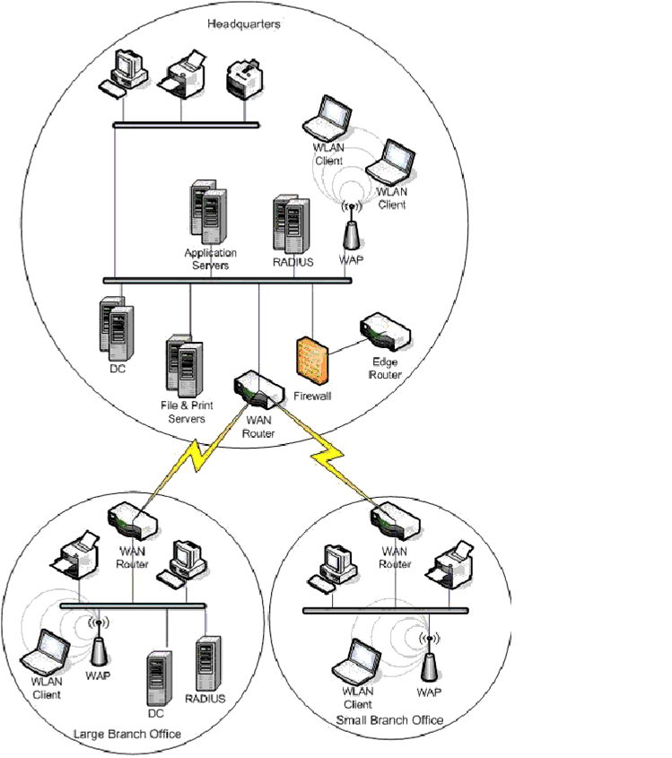
Fig 1.1

Second one network alternative architectures that fulfill the objectives of the project, look like this:
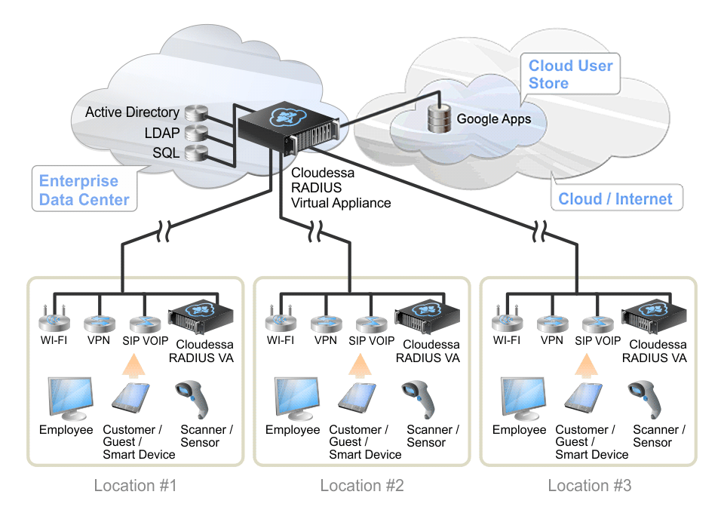
Fig 1.2
Pros and Cons of both Alternative Architecture

Alternative | Pros | Cons
First | Isolation of network devices is accomplished in this star topology. The operation of information transmission is less complex because of its temperament of centralization. Data exchanged between two hubs goes through the hubs introduce in the middle of the source and the goal hubs. For overseeing topology, a different central server is not required. | The central hub accomplishes the principle functionality of the network devices in this topology. On the off chance that the focal center point falls flat, the information move in the whole system gets influenced. Repetition of the system association happens in this topology since when one hub is associated with many centers, the reason for some relationships in the system between hubs is no reason.
Second | By combining thousands of servers preparing force and capacity limit, appropriated systems is to a high degree great looks at to centralized computer or super PC. A few applications like the web, email, texting, easy organization, and so forth are typically distributed. The mainframe is excessively costly analyzes, making it impossible to purchasing a few product servers. | Security is the most concerning issue in each figuring. Networking systems likewise should be composed not to be effortlessly bargained. It requires lots of skills with various programming stages to construct massive interactive software stack.
(Moozakis)
Security Implications For First Alternatives
This network architecture has the great security implication concept such as this architecture using some security ideas that are listed below:
- Not deploying WLAN technology
- Using WPA with PEAP-MS-CHAP v2, and Certificate Services
- Using WPA with EAP-TLS
- Using a VPN
- Using WEPUsing IPsec
- Using WPA with PEAP-MS-CHAP v2
- No WLAN Security (cisco)
Security Implications For second Alternatives
This architecture has some more benefit able security concepts that are listed below:
- Flexible Security
- Seamless integration with a back-end data store
- Support flexible safety requirements, to quickly enable access to employees and guests/customers
- Use Cloudessa RADIUS in the public cloud, or deploy on a distributed basis in a private cloud
- Centralized Management, Distributed Deployment (google)
Recommend Architecture
I Recommend other architecture because this architecture full fill all over the organization needs such as most multi-location organizations pick not to staff every branch area with IT faculty. As a result of this, a WiFi framework that can be halfway kept up from the central command area is vital. One center component of an active WiFi organize establishment is a RADIUS server, for example, Cloudessa RADIUS. Sweep is the standard for securing access to WiFi arranges, and deals with the verification, approval, and bookkeeping of all system get to. Most multi-location organizations pick not to staff every branch area with IT faculty. As a result of this, a WiFi framework that can be halfway kept up from the central station area is vital (cisco).

References
cisco. (n.d.). Cisco Unified Wireless Network Architecture . Retrieved from cisco: http://www.cisco.com/c/en/us/td/docs/solutions/Enterprise/Mobility/emob73dg/emob73/ch4_Secu.pdf
cisco. (n.d.). Wireless and Network Security Integration Solution Design Guide. Retrieved from cisco: http://www.cisco.com/c/en/us/td/docs/solutions/Enterprise/Mobility/secwlandg20/sw2dg/ch4_2_SPMb.html
google. (n.d.). Network Architecture & Types of Network. Retrieved from google: https://sites.google.com/site/mrstevensonstechclassroom/home/strand-3-it-systems/3-3-networks/client-server-networks
Moozakis, C. (n.d.). New network architectures and traditional components. Retrieved from techtarget: http://searchnetworking.techtarget.com/feature/New-network-architectures-and-traditional-components-Why-both-are-key
toronto. (n.d.). classification of Computer Networks . Retrieved from toronto: http://www.cs.toronto.edu/~marbach/COURSES/CSC358_S14/classification.pdf

